**DAILY ONLINE ACTIVITIES SUMMARY**

|  |  |  |  |  |  |  |  |  |
| --- | --- | --- | --- | --- | --- | --- | --- | --- |
| **Date:** | **19-5-2020** | | | | | **Name:** | **poojashree** | |
| **Sem & Sec** | **8th sem A sec** | | | | | **USN:** | **4al16cs065** | |
| **Online Test Summary** | | | | | | | | |
| **Subject** | | **Bda** | | | | | | |
| **Max. Marks** | | **30** | | **Score** | | | **21** | |
| **Certification Course Summary** | | | | | | | | |
| **Course** | **Introduction to front end development** | | | | | | | |
| **Certificate Provider** | | | **Great learning academy** | | **Duration** | | | **3.5hr** |
| **Coding Challenges** | | | | | | | | |
| **Problem Statement:** **to add some of the letters given then find shortest palindrome possible**  **To check whether linked list is palin or not** | | | | | | | | |
| **Status:completed** | | | | | | | | |
| **Uploaded the report in Github** | | | | | **yes** | | | |
| **If yes Repository name** | | | | | **Poojashree1998** | | | |
| **Uploaded the report in slack** | | | | | **yes** | | | |

Online test

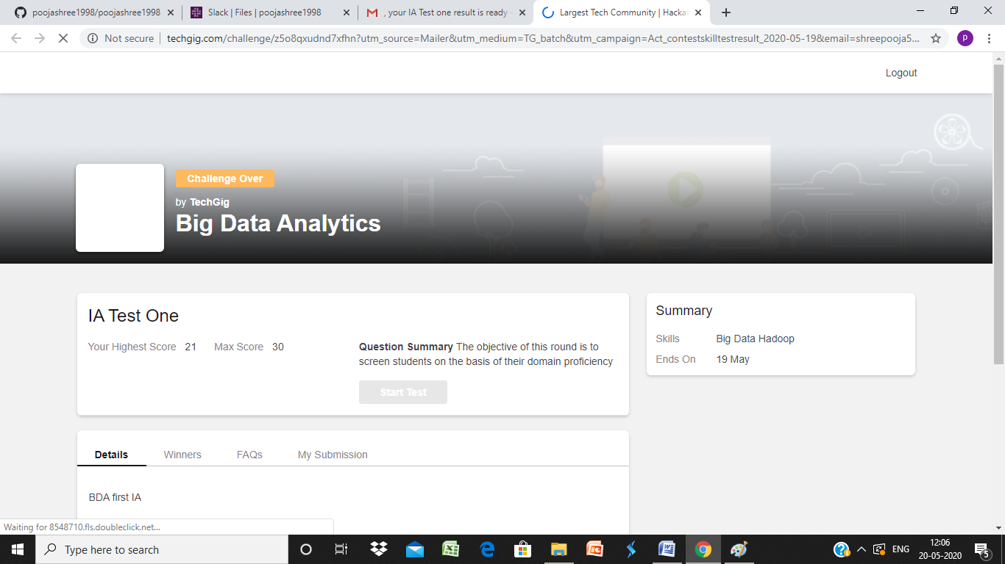

Certification course

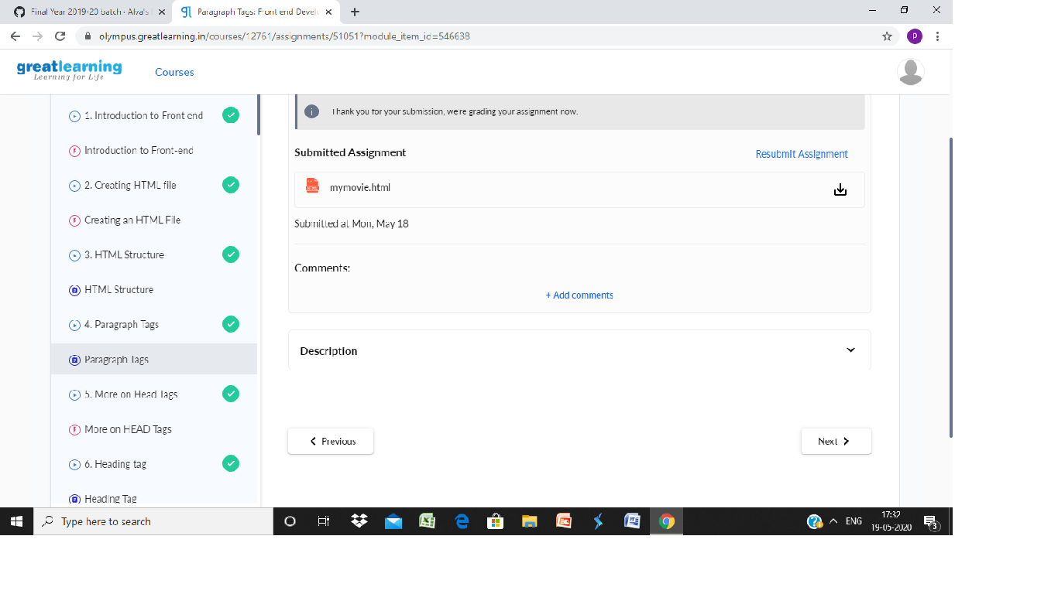

Coding

**Program 1**package shortestpalindromeexample.java;  
import java.util.Scanner;

public class ShortestPalindromeDemo {

public static String shortestPalindrome(String str) {

int x=0;  
int y=str.length()-1;

while(y>=0){  
if(str.charAt(x)==str.charAt(y)){  
x++;  
}  
y--;  
}

if(x==str.length())  
return str;

String suffix = str.substring(x);  
String prefix = new StringBuilder(suffix).reverse().toString();  
String mid = shortestPalindrome(str.substring(0, x));

return prefix+mid+suffix;  
}

public static void main(String[] args) {

Scanner in = new Scanner(System.in);

System.out.println("Enter a String to find out shortest palindrome");

String str=in.nextLine();

System.out.println("Shortest palindrome of "+str+" is "+shortestPalindrome(str));

}

**Program2**  
import java.util.Stack;

class Node {  
int data;  
Node next;

Node(int i)  
{  
this.data = i;  
this.next = null;  
}  
};

class Main  
{  
// Function to determine if a given linked list is palindrome or not  
public static boolean isPalindrome(Node head)  
{  
// construct an empty stack  
Stack s = new Stack<>();

// push all elements of the linked list into the stack  
Node node = head;  
while (node != null) {  
s.push(node.data);  
node = node.next;  
}

// traverse the linked list again  
node = head;  
while (node != null)  
{  
// pop the top element from the stack  
int top = s.pop();

// compare the popped element with current node's data  
// return false if mismatch happens  
if (top != node.data) {  
return false;  
}

// advance to the next node  
node = node.next;  
}

// we reach here only when the linked list is palindrome  
return true;  
}

public static void main(String[] args)  
{  
Node head = new Node(1);  
head.next = new Node(2);  
head.next.next = new Node(3);  
head.next.next.next = new Node(2);  
head.next.next.next.next = new Node(1);

if (isPalindrome(head)) {  
System.out.print("Linked List is a palindrome.");  
} else {  
System.out.print("Linked List is not a palindrome.");  
}  
}  
}